P3 Revision pack mark scheme
1.

2

3
4.

5.
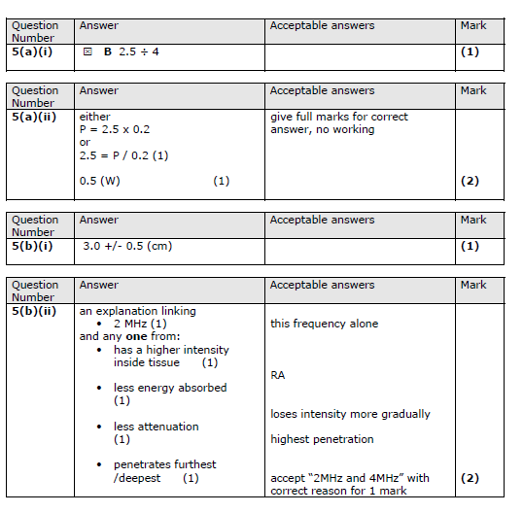

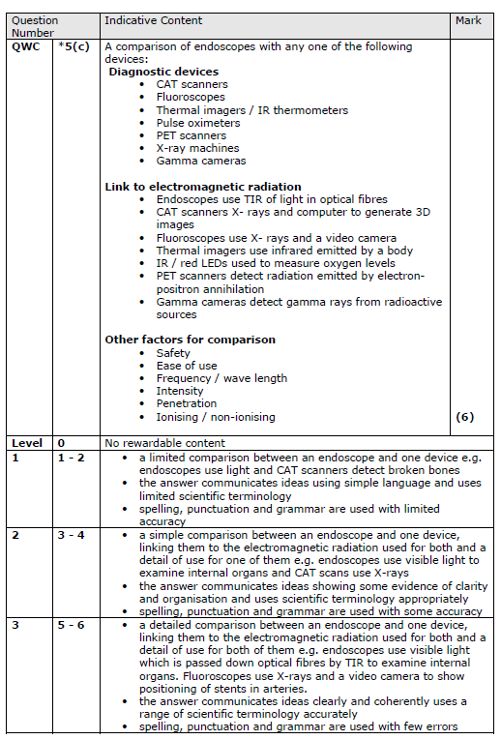
6.
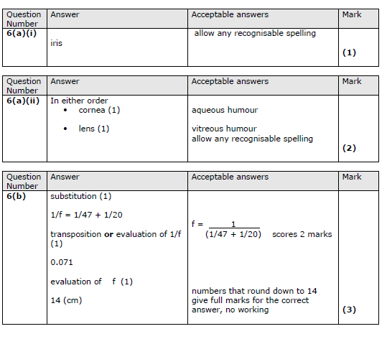
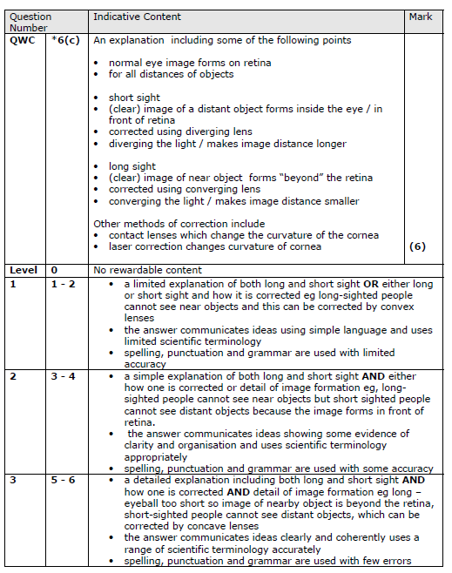

7.

8.

9.

10. Explain how X-rays are produced

Level | Marks | Content
1 | 1-2 | - A limited description of the key points.  - Simple language, limited scientific terminology.  - Poor spelling, punctuation and grammar.
2 | 3-4 | - A detailed description of some of the key points.  - Some evidence of clarity and organisation and uses scientific terminology appropriately.  - Spelling, punctuation and grammar are used with some accuracy.
3 | 5-6 | - A detailed description of all of the relevant key points.  - Clear coherent communication. Accurate use of key words.  - Few spelling/grammar errors.

A good answer will include the following points:
  - there is an evacuated tube containing an anode and a cathode
  - the cathode is an electron gun
  - electrons are accelerated to the anode
  - electrons collide with the anode
  - most of the kinetic energy of the electrons is transferred to thermal energy
  - some of the kinetic energy is transformed to X-rays

11.
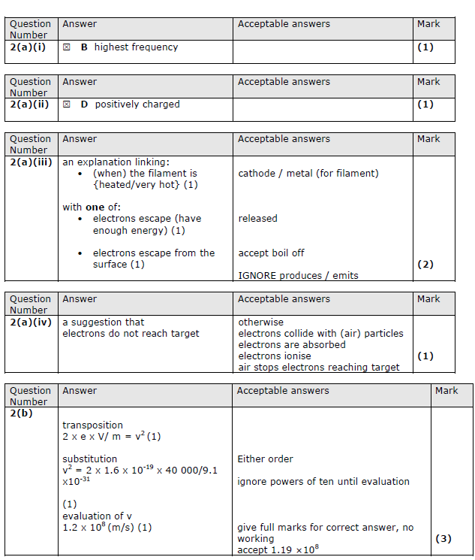

12.

13.

14.

15.

Q16.
 | Answer | Acceptable answers | Mark
(a)(i) | 2.5 (m) | Allow answers between (and including) 2.45 & 2.55 | (1)
(a)(ii) | 0.7 (s) | Allow answers between (and including) 0.68 & 0.72 | (1)
(a)(iii) | 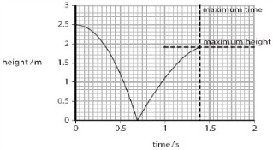  line: same shape as original (1) peak at 1.9 m (1) time taken < 0.7 s (1) | Ignore any part of the graph after the peak | (3)
(a)(iv) | An explanation linking: energy lost (1) in collision with ground / air resistance (1) | Inelastic collision worth (2)  as sound or heat | (2)
(b)(i) | shown using data  Any two from  kinetic energy before = 12.5 + 0  (=12.5) (1)  kinetic energy after = 4.5 + 8  (=12.5)  (1) Kinetic energy is the same before and after the collision (1) | Kinetic energy is conserved/no energy lost | (2)
(b)(ii) | cyclotron (1) | named particle accelerator accept CERN | (1)

Q17.
 | Answer | Acceptable answers | Mark
(a)(i) | momentum = 0.03 × 170 (1) | Accept 5.1 seen | (1)
(a)(ii) | momentum before = momentum after (1) 5.1 = 0.83 × v (1) v = 6.1 (m/s) (1) | allow 5.0 = 0.80 x v for 1 mark max 5.0 = 0.83 × v v = 6.0 (m/s)  allow ecf from (a)(i) give full marks for correct answer, no working | (3)
(a)(iii) | Statement to include any two from  • kinetic energy is not conserved (1)  • (lost ke) appears as heat/sound (1)  • momentum is conserved (1) | ke not conserved / some ke lost no momentum lost | (2)
(b)(i) | an explanation linking  • momentum (must be) conserved (1)  • so must have positive and negative momentum (1) | photons move in opposite directions indication of movement in  opposite directions (e.g. opposite velocities) | (2)
(d)(ii) | E = (2 ×) 9.1 × 10⁻³¹ × [3 × 10⁸]² (1) = 1.6 × 10⁻¹³ (J) (1) | 8.2 × 10⁻¹⁴ (0.82 × 10⁻¹³) for 1 mark give full marks for correct answer, no working | (2)

Q18.
Question  Number |  | Indicative content | Mark
QWC | * | An explanation linking some of the following points  Circular Motion (A)  - Protons placed in centre of cyclotron  - Particle accelerated by electric field across gap  - Magnetic fields bends the path of protons  - Particle moves in circular path due to centripetal force (CPF: magnetic F)  - This F acts at right angles and towards circle centre  Energy and bombardment (B)  - KE and MOM increases as its accelerated (spiral)  - Proton leaves cyclotron in a straight line (no more CPF)  - Proton bombards stable Oxygen-18 atoms to produce the positron-emitting radioisotope Fluorine-18  Reasons for being in hospital (C)  - Produced on demand  - Half-life short  - This happens close to the PET scanner.  - Risk of ionising radiation escaping is reduced | (6)
Level | 0 | No rewardable material
1 | 1-2 | A limited explanation mentioning any two from A or one from B or A  • the answer communicates ideas using simple language and uses limited scientific terminology • spelling, punctuation and grammar are used with limited accuracy
2 | 3-4 | • A simple explanation linking aspects of two ideas i.e. A + B OR A + C OR A + C  • the answer communicates ideas showing some evidence of clarity and organisation and uses scientific terminology appropriately • spelling, punctuation and grammar are used with some accuracy
3 | 5 - 6 | • A detailed explanation linking A + B + C  • the answer communicates ideas clearly and coherently uses a range of scientific terminology accurately • spelling, punctuation and grammar are used with few errors

19.
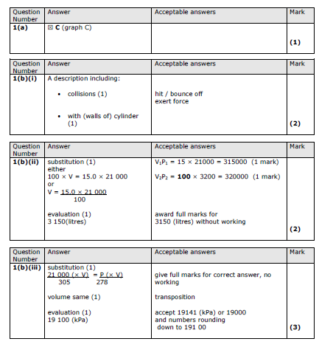
20.

21.
22.

23.

