A2 Chemistry
F325
Equilibria, Energetics and Elements

Transition Elements

Assessment Outcomes
Candidates should be able to:

Properties
(a) Deduce the electron configurations of atoms and ions of the d-block elements of Period 4 (Sc–Zn), given the atomic number and charge;
(b) Describe the elements Ti–Cu as transition elements, i.e. d-block elements that have an ion with an incomplete d sub-shell;
(c) Illustrate:
(i) The existence of more than one oxidation state for each element in its compounds,
(ii) The formation of coloured ions,
(iii) The catalytic behavior of the elements and/or their compounds;

Precipitation Reactions
(d) describe, including ionic equations, the simple precipitation reactions and the accompanying colour changes of Cu2+(aq), Co2+(aq), Fe2+(aq) and Fe3+(aq) with aqueous sodium hydroxide;

Ligands and Complex Ions
(e) Explain the term ligand in terms of coordinate bonding;
(f) State and use the terms complex ion and coordination number;
(g) State and give examples of complexes with six fold coordination with an octahedral shape;
(h) Explain and use the term bidentate ligand (e.g. NH2CH2CH2NH2, ‘en’);
(i) Describe the types of stereoisomerism shown by complexes, including those associated with bidentate and multidentate ligands:
(i) cis-trans isomerism, e.g. Ni(NH3)2Cl2,
(ii) Optical isomerism, e.g. [Ni(NH2CH2CH2NH2)3]2+;
(j) Describe the use of cis-platin as an anticancer drug and its action by binding to DNA in cancer cells, preventing division;

Ligand substitution
k) Describe the process of ligand substitution and the accompanying colour changes in the formation of:
(i) [Cu(NH3)4(H2O)2]2+ and [CuCl4]2– from [Cu(H2O)6]2+,
(ii) [CoCl4]2– from [Co(H2O)6]2+;
(l) Explain the biochemical importance of iron in haemoglobin, including ligand substitution involving O2 and CO;
(m) State that the stability constant, Kstab,, of a complex ion is the equilibrium constant for the formation of the complex ion in a solvent from its constituent ions;
(n) Deduce expressions for the stability constant, Kstab, of a ligand substitution, e.g. M2+(aq) + 6X–(aq) ⇌ MX6
4–(aq) Kstab = [MX6 4–(aq)]/[M2+(aq)][X–(aq)]6
(o) Relate ligand substitution reactions of complexes to stability constants and understand that a large Kstab results in formation of a stable complex ion.

TRANSITION ELEMENTS

A Transition Element is defined as a d-block element is an element that forms one or more stable ions that have partially filed d orbitals

Electronic Configuration

The outer electronic configuration of elements in the first row of the d-block is as follows:
4s 3d

Sc | [Ar] |  | ↑↓ |  | ↑
Ti | [Ar] |  | ↑↓ |  | ↑ | ↑
V | [Ar] |  | ↑↓ |  | ↑ | ↑ | ↑
Cr | [Ar] |  | ↑ |  | ↑ | ↑ | ↑ | ↑ | ↑
Mn | [Ar] |  | ↑↓ |  | ↑ | ↑ | ↑ | ↑ | ↑
Fe | [Ar] |  | ↑↓ |  | ↑↓ | ↑ | ↑ | ↑ | ↑
Co | [Ar] |  | ↑↓ |  | ↑↓ | ↑↓ | ↑ | ↑ | ↑
Ni | [Ar] |  | ↑↓ |  | ↑↓ | ↑↓ | ↑↓ | ↑ | ↑
Cu | [Ar] |  | ↑ |  | ↑↓ | ↑↓ | ↑↓ | ↑↓ | ↑↓
Zn | [Ar] |  | ↑↓ |  | ↑↓ | ↑↓ | ↑↓ | ↑↓ | ↑↓

Note the unusual structures of chromium and copper. The 4s and 3d subshells are very similar in energy and therefore it is easy to promote electrons from the 4s into the 3d orbitals.

In chromium the 4s¹3d⁵ structure is adopted because the repulsion between two paired electrons in the 4s orbital is more than the energy difference between the 4s and 3d subshells. It is thus more stable to have unpaired electrons in the higher energy 3d orbital than paired electrons in the lower energy 4s orbital.

In copper and zinc the 3d subshell is actually lower in energy than the 4s subshell. The 3d orbitals are thus filled before the 4s orbital. Thus copper adopts a 4s¹3d¹⁰ configuration.

In all ions of d-block elements, the 3d subshell is lower in energy than the 4s subshell so the 4s electrons are always removed first. 3d electrons are only removed after all 4s electrons have been removed.

Some examples of electronic configurations of transition metal ions are shown below:

4s 3d
V²⁺ | [Ar] |  |  |  | ↑ | ↑ | ↑
Cr³⁺ | [Ar] |  |  |  | ↑ | ↑ | ↑
Mn²⁺ | [Ar] |  |  |  | ↑ | ↑ | ↑ | ↑ | ↑
Other Properties

- When oxidized they lose electrons from 4s subshell first then 3d
- Transition Metals can exist in several oxidation states
- TM are good catalysts because they can transfer electrons easily and provide a site for the reaction to take pace

Some typical reactions catalyzed by transition metals follow.
- Haber Process: [Fe₂O₃, 500 °C, 400 atm]
N₂ + 3 H₂ 2 NH₃
- Contact Process: [V₂O₅, 400 °C]
2 SO₂ + O₂ 2 SO₃
- Hydrogenation: [H₂ /Ni @ 25 °C, 1 atm]
CH₂=CH-CH₂CH₃ CH₃CH₂CH₂CH₃
- Catalytic Converters: [Pd or Rh]
CO + HC’s + O₂ CO₂ + H₂O
NO and NO₂ → N₂ + O₂
- TM are often coloured
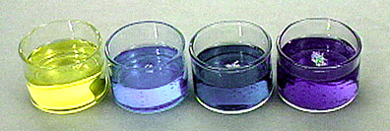

E.g. Vanadium compounds vary in colour based on their oxidation state.
From left to right: V⁺⁵, V⁺⁴, V⁺³, V⁺²

- They form complex ions with ligands
- TM react with aqueous hydroxide ions to give precipitates. The colour of the precipitate formed can be used to identify the TM ion present

Ion in solution | Reaction with a few drops of NaOH_{(aq)} or NH_{3(aq)} | Reaction with excess NaOH_{(aq)} | Reaction with excess NH_{3(aq)}
Mn²⁺ | Beige ppt | No further reaction
Fe²⁺ | Pale green to Dirty green ppt | No further reaction | No further reaction
Fe³⁺ | Yellow to Red-brown ppt | No further reaction | No further reaction
Ni²⁺ | Green gelatinous ppt | No further reaction | Ppt dissolves to form a blue solution
Cu²⁺ | Pink to Blue ppt | No further reaction | Ppt dissolves to form a deep blue solution

A simple way of looking at these is as hydroxide ions adding to the transition metal ion – the number of hydroxide ions being equal to the charge on the ion.

[M(H₂O)_{x}]^{y+} + yOH⁻ → [M(H₂O)_{x-y}(OH)_{y}] + yH₂O

Oxidation States

The oxidation state formed by an element in its compounds is determined by the maximum number of electrons it can lose without requiring so much energy to remove the electrons that the energy cannot be recovered in bonding.

s-block elements only form one stable oxidation state in their compounds. They lose all their valence electrons easily but cannot lose any more electrons since there is a large amount of energy required to remove the electrons from the inner shell.

This jump in energy is best shown graphically:

E.g. Na E.g. Mg

Na always adopts the +1 oxidation state in its compounds because there is a large jump between the first and the second ionisation energies.
Mg always adopts the +2 oxidation state in its compounds because there is a small jump between the first and the second ionisation energies but a very large jump between the second and third ionisation energies.

In the d-block elements, however, there are often a large number of valence electrons and removing them all would require so much energy that it would be unfeasible. It is usually only possible to remove some of the valence electrons. All d-block elements can give up their 4s electrons fairly easily but the d-electrons are harder to remove.
Moreover, since the successive ionisation energies of d-electrons increase steadily, it is difficult to predict how many can be lost.

This effect can be shown graphically by considering the successive ionisation energies of an element such as manganese:

The ionisation energies increase steadily after the removal of the 4s electrons. It turns out that the energy required to remove the 3d electrons is sometimes recovered in bonding, but not always. The number of 3d electrons removed thus varies from compound to compound

d-block metals are therefore able to adopt a variety of oxidation states.

The oxidation states most commonly formed by the first-row d-block elements are as follows:

Sc: +3 only (d⁰)
Ti: +3 (d¹), +4 (d⁰)
V: +2 (d³), +3 (d²), +4 (d¹), +5 (d⁰)
Cr: +3 (d³), +6 (d⁰)
Mn: +2 (d⁵), +3 (d⁴), +4 (d³), +6 (d¹), +7 (d⁰)
Fe: +2 (d⁶), +3 (d⁵)
Co: +2 (d⁷), +3 (d⁶)
Ni: +2 (d⁸)
Cu: +1 (d¹⁰), +2 (d⁹)
Zn: +2 only (d¹⁰)

It is sometimes possible to remove all 3d electrons to form a dº configuration. However for elements beyond manganese it is unusual to find an oxidation state containing fewer than 5 3d electrons. The d⁵ configuration is quite stable because paired d-electrons can be removed to reach d⁵ but unpaired electrons must be removed to reach d⁴. Unpaired electrons are harder to remove because there is less repulsion between the electrons.

Note that scandium only forms +3 ions (d⁰). This is because the low effective nuclear charge on scandium enables all three valence electrons to be removed fairly easily.

Note also that zinc only forms +2 ions (d¹⁰). This is because the high effective nuclear charge on zinc prevents any 3d electrons from being removed.

All the other elements form at least one stable ion with partially filled d-orbitals, and it is this property which defines a transition metal.

A transition metal is a metal which forms at least one stable ion with partially filled d-orbitals.

Since zinc and scandium do not share this property, they are not transition metals, and indeed do not show many of the properties generally attributed to transition metals. They are however still classified as d-block elements.

The first row d-block elements which are also transition metals are therefore titanium, vanadium, chromium, manganese, iron, cobalt, nickel and copper.

COMPLEX IONS

A complex ion is defined as a central metal ion surrounded by ligands

A ligand is defined as a molecule or ion that bonds to a metal ion by forming a coordinate (dative covalent) bond by donating a one pair of electrons into a vacant d orbital.

Examples of ligands are H₂O, NH₃, Cl⁻, OH⁻, CN⁻,

Cations which form complex ions must have two features:

- they must have a high charge density, and thus be able to attract electrons from ligands.

- they must have empty orbitals of low energy, so that they can accept the lone pair of electrons from the ligands.

Cations of d-block metals are small, have a high charge and have available empty 3d and 4s orbitals of low energy. They thus form complex ions readily.

The number of lone pairs of electrons which a cation can accept is known as the coordination number of the cation.

It depends on the size and electronic configuration of that cation, and also on the size and charge of the ligand. 6 is the most common coordination number, although 4 and 2 are also known.

Examples of complex ions are [Fe(H₂O)₆]²⁺, [CoCl₄]²⁻, [Cu(NH₃)₄(H₂O)₂]²⁺. Note that the formula of the ion is always written inside square brackets with the overall charge written outside the brackets.

Shapes of Complex Ions

6-coordinate complexes are all octahedral, and are formed with small ligands such as H₂O and NH₃. They can thus be drawn as follows:

[Fe(H₂O)₆]²⁺ [Cr(NH₃)₆]³⁺ [Cu(NH₃)₄(H₂O)₂]²⁺

4-coordinate complexes are generally tetrahedral, and are formed with larger ligands such as Cl⁻. Larger ligands cannot fit around the transition metal so easily and hence form smaller complexes. They can be drawn as follows:

[CoCl₄]²⁻

2-coordinate complexes are in general linear, and are formed with Ag⁺ ions. They can be drawn as follows:

[Ag(NH₃)₂]⁺

The rules covering the likely coordination number of transition metal complexes are:

a) Silver ions form linear complexes with a coordination number of 2;

b) Chloride ions and other large ions form tetrahedral complexes with a coordination number of 4;

c) Most other transition metal complexes are octahedral with a coordination number of 6.

Isomerism

Geometric isomers

Isomers where the atoms are bonded in the same way but differ because some atoms occupy different relative positions in space.

Cisplatin (diamminedichloroplatinum(II)) two compounds are known with this composition. One is orange yellow and is somewhat soluble in water and acts as a cancer-fighting drug. The other is yellow and is much less soluble and doesn't have the cancer fighting ability. With four ligands there are two possibilities for the structure; tetrahedral and square planar.
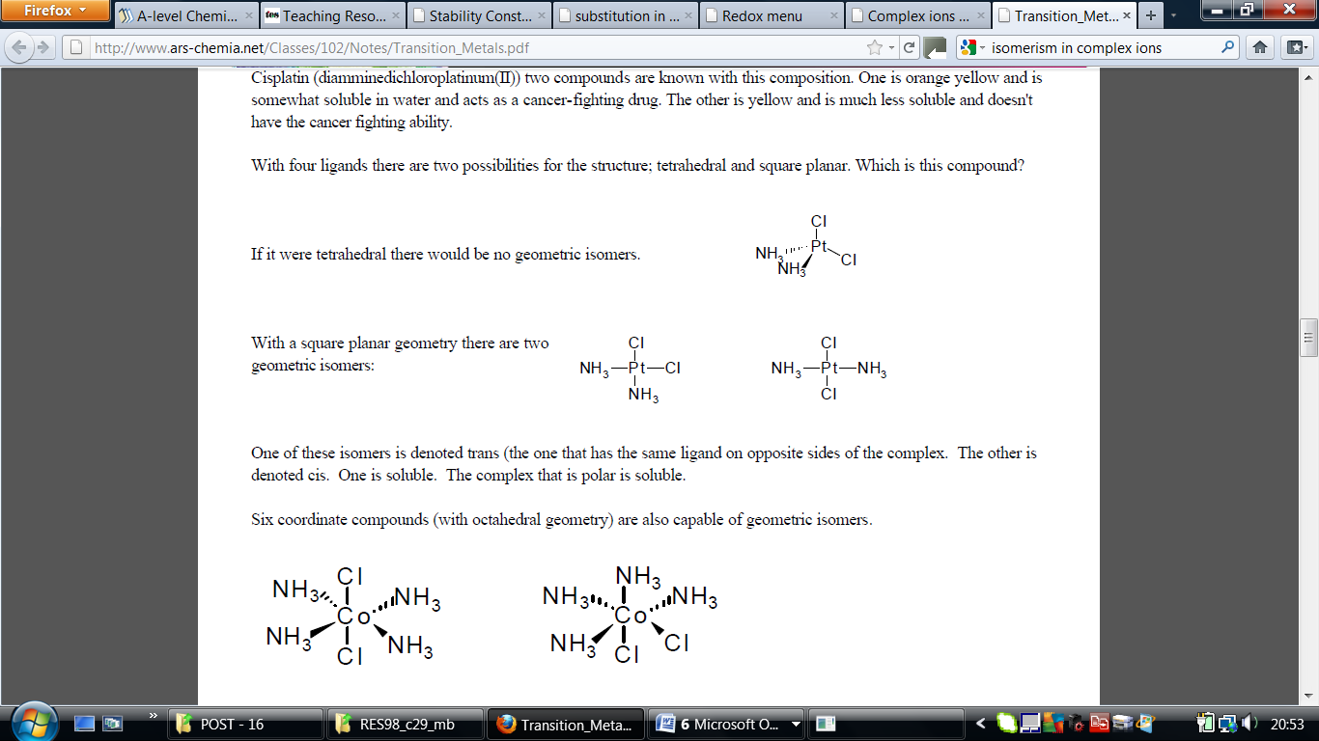

Trans implies "opposite" - notice that the ammonias are arranged opposite each other in that version, and so are the chlorines. Cis implies "on the same side".
Optical Isomers
Optical Isomers have NO plane of symmetry. All attached groups are different. However in complex ions, this is not so easy.
The examples you are most likely to need occur in octahedral complexes which contain bidentate ligands - ions like [Ni(NH₂CH₂CH₂NH₂)₃]²⁺ or [Cr(C₂O₄)₃]³⁻.
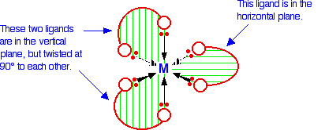
Although it is difficult to see, this is an optical isomer; the two isomers are below:
